how to create dashboard-

1. select Profiles in profile we see two device profile and asset profile.

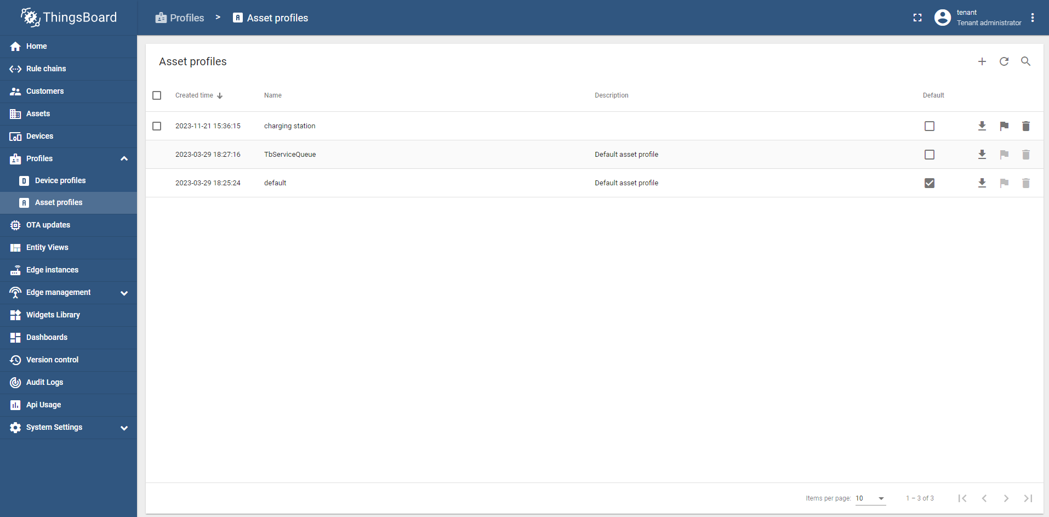

**3**

**2**

**1**

2. go in asset profile and create one asset profile.

1. we see assets on left side select created assets then create assets based on number of ports create assets.

2. now click on asset name then see on top click on attributes in Server attributes add key and value. *we have to do this thing with all assets.

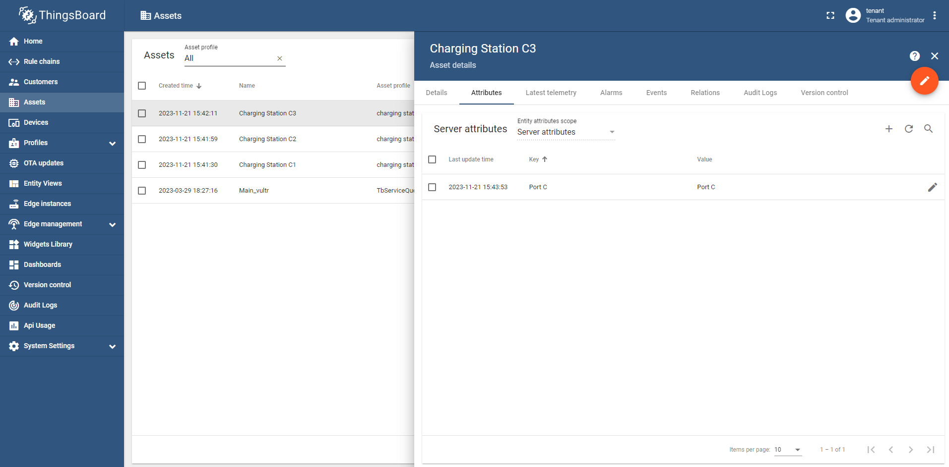

**1**

**2**

**3**

**4**

**5**

3. remember we have to give asset profile in all assets what we created.

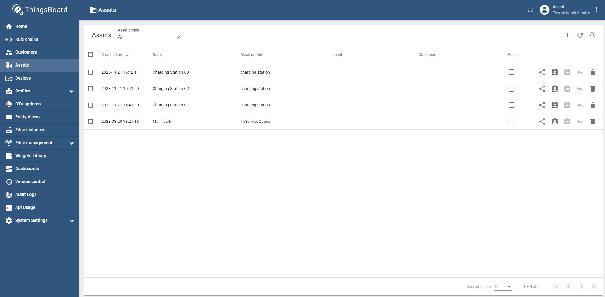

3. for device also we have to create device profile only one profile is enough.

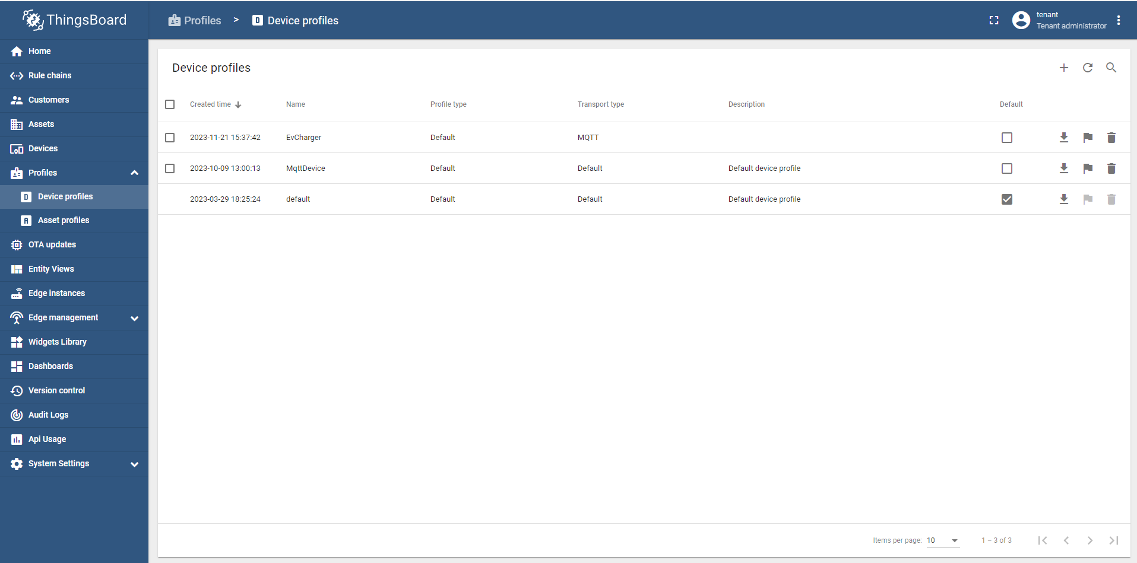

**22**

**1**

**3**

1. we see devices on left side select then create devices based on number of ports create device.

*for communication access token we get here.

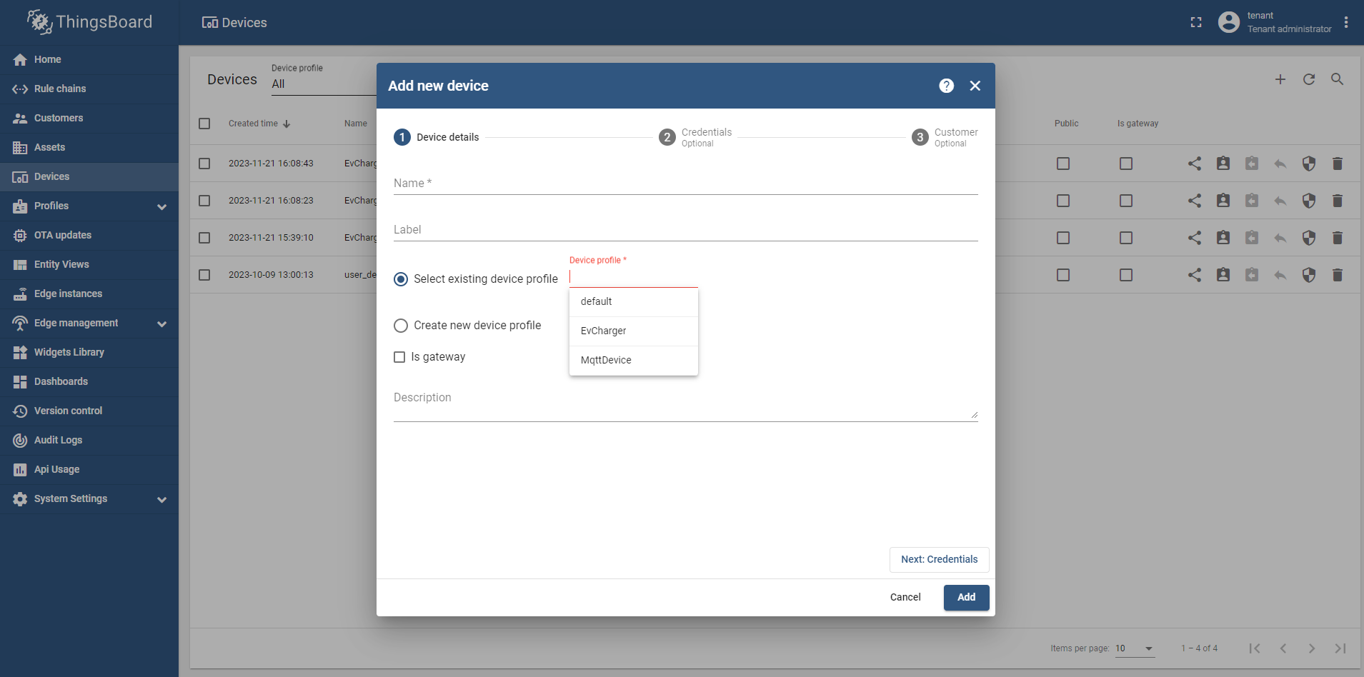

**1**

**1**

**1**

2. remember we have to give device profile in all devices what we created.

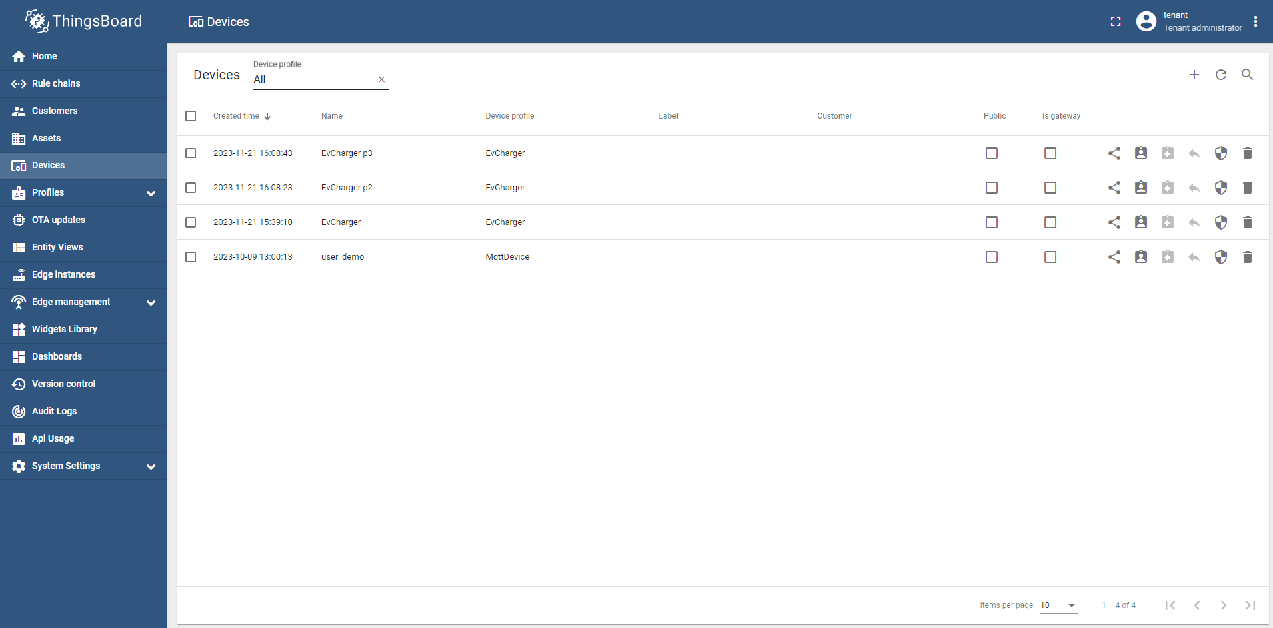

4. click on dashboard in left side-

1. create new dashboard.

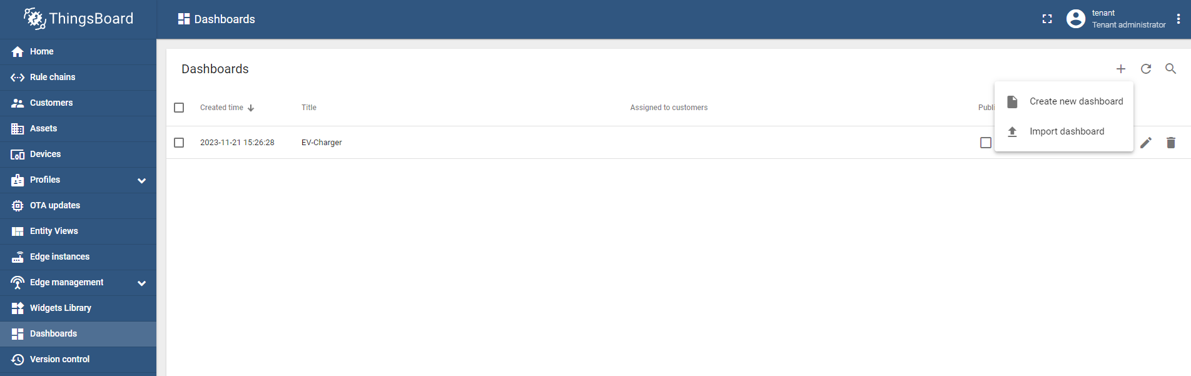

**1**

2. give dashboard name.

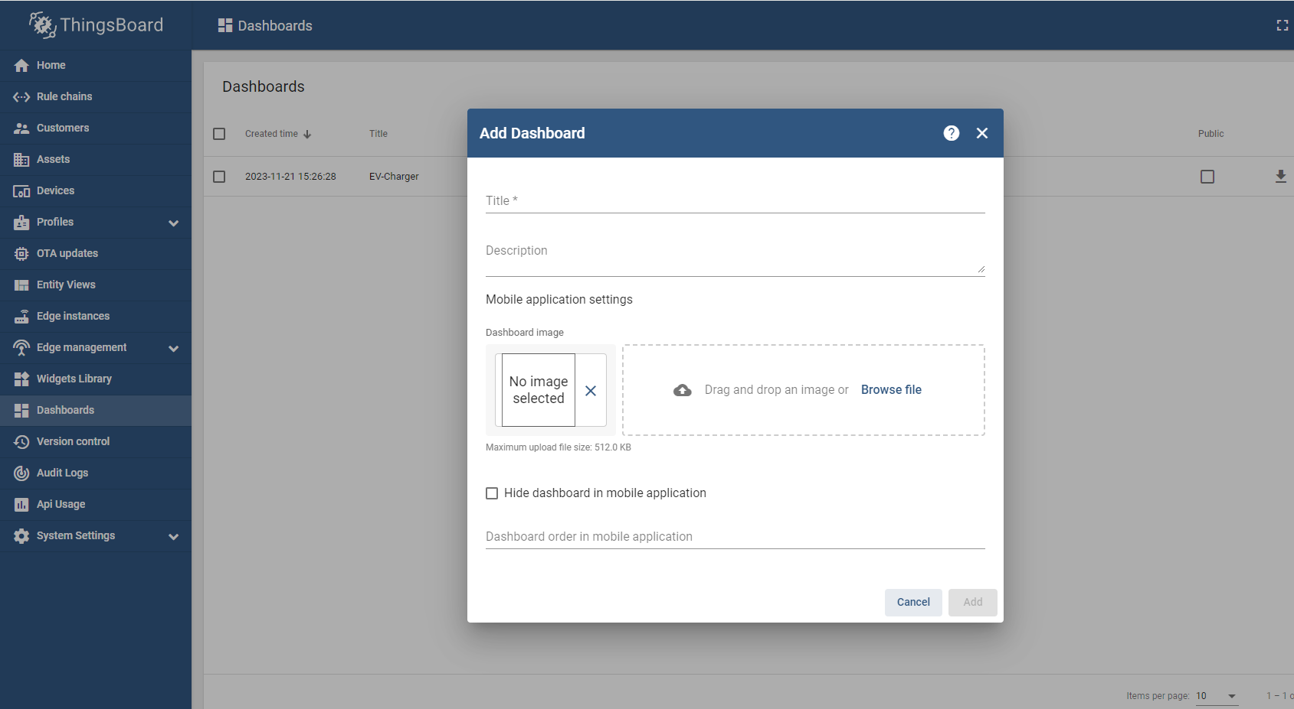

**2**

3. create entity alias.

1. In the upper right corner of the window, click the “Entity alias” icon.

2. In the opened Entity aliases window, click the “Add alias” button on the left side of the dialog box.

3. In the opened dialog *Add alias*, enter a name for the alias, select a *Single entity* filter type. From the Type drop-down menu, Select the *Device* and enter the name of the needed device (start typing it and it will be found automatically).

4. After configuring the alias, click the “Add” button in the lower right corner.

5. We can now see that a new alias has been added. Click “Save” in the lower right corner of the dialog box.

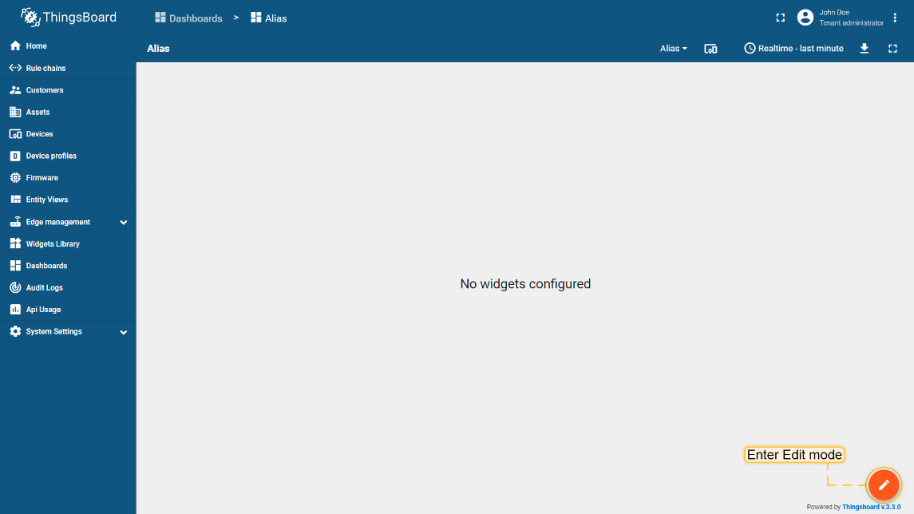

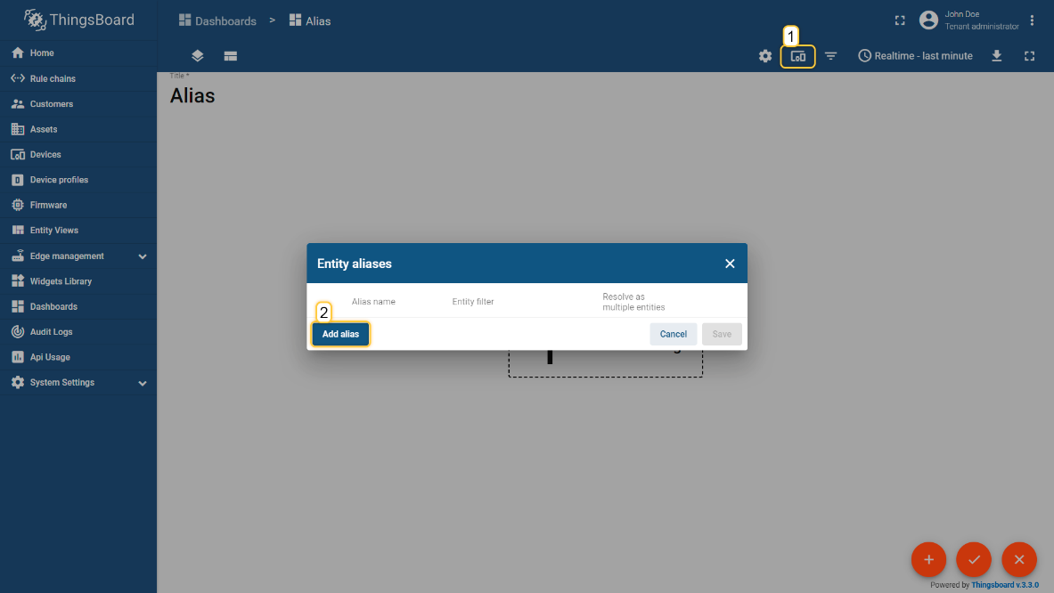

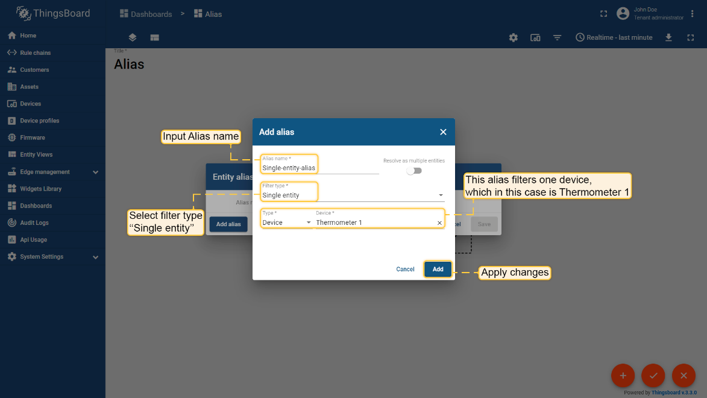

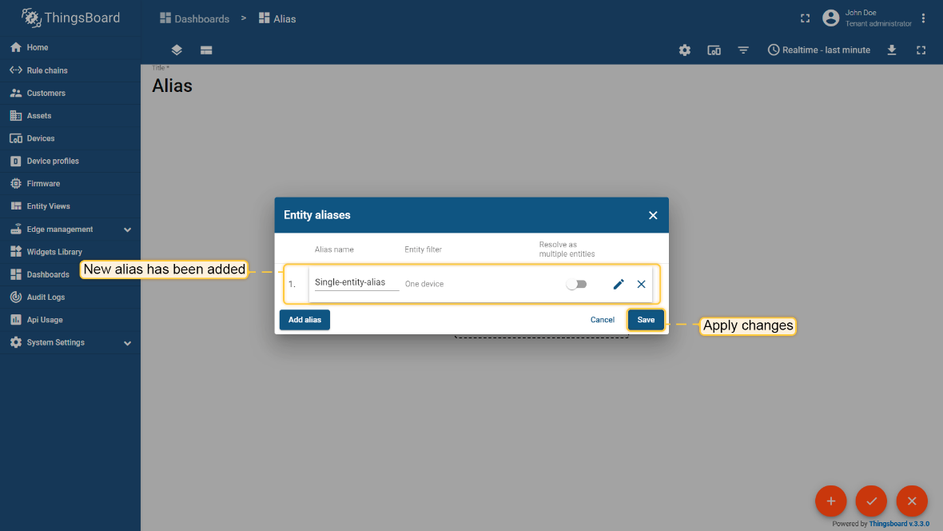

After add **Entity aliases** click on edit option.

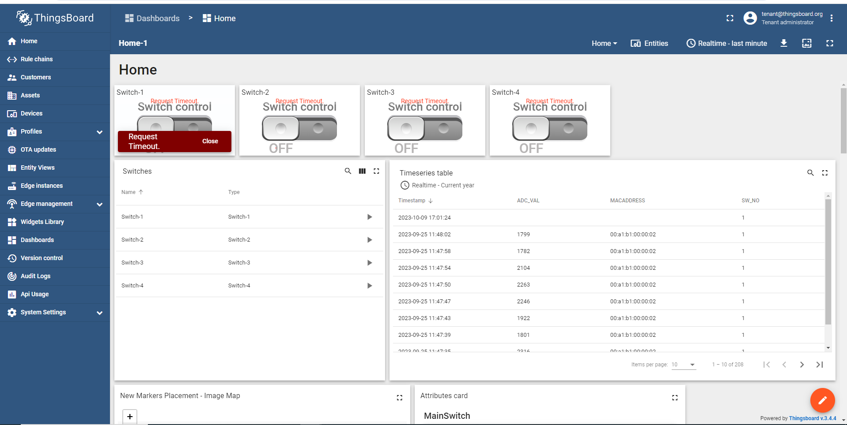

**1**

Click on **Add** option.

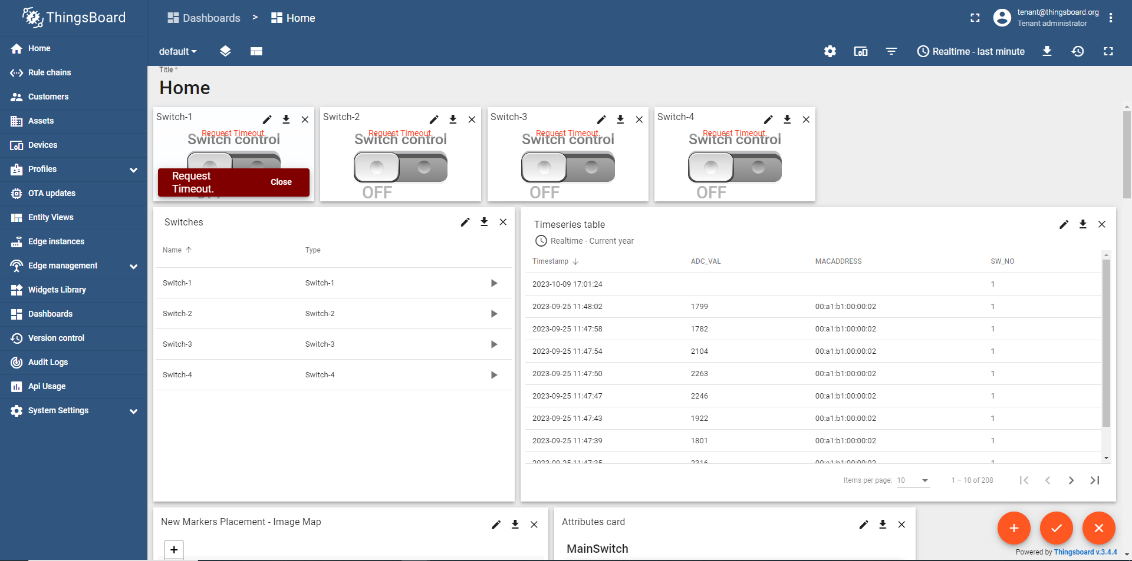

**2**

Then you can see the **create new widget** option which is second -> click on that.

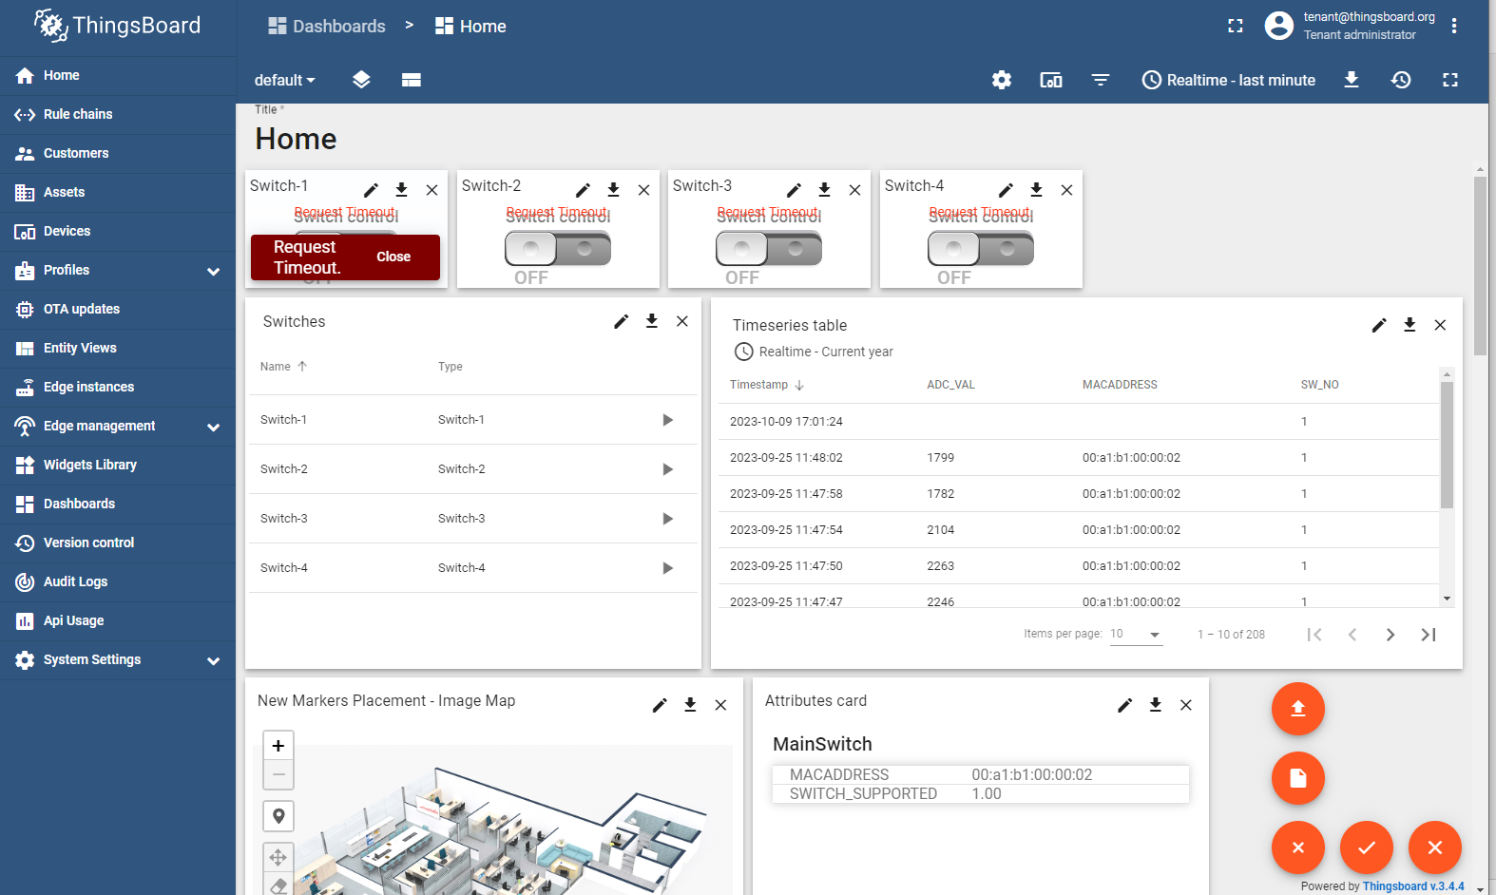

**3**

**Select Control** Widgets for select -> **Switch Control.**

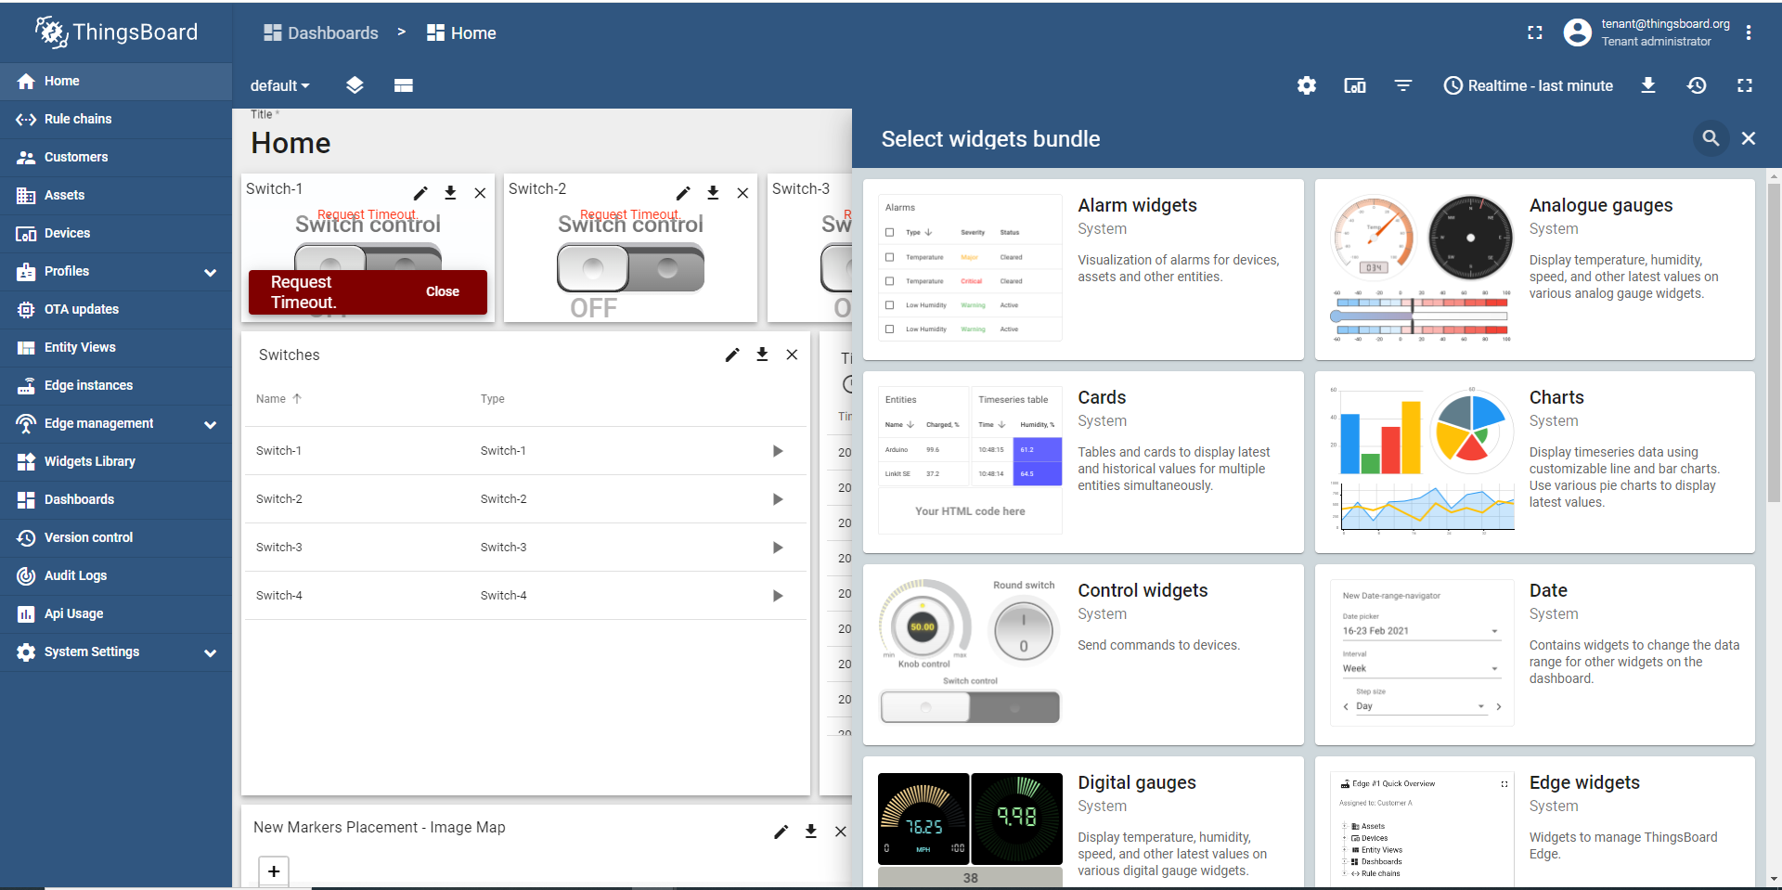

**4**

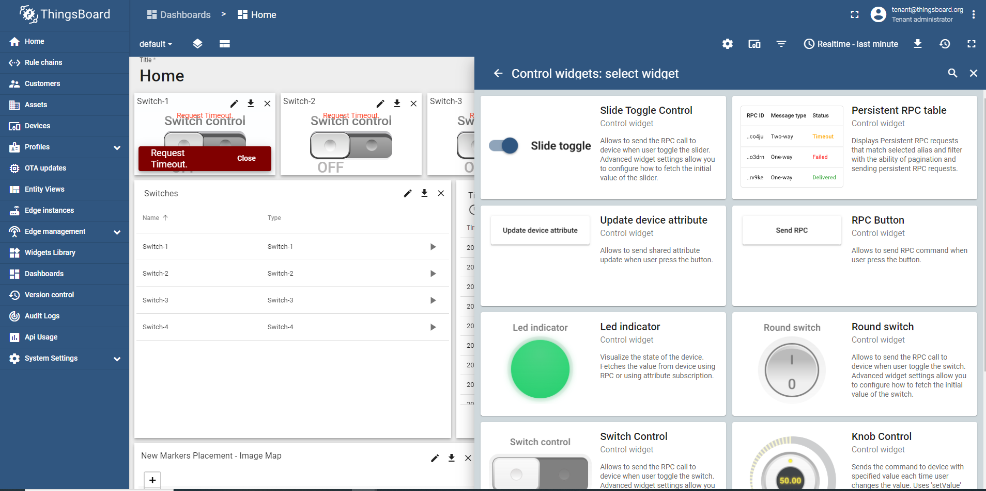

**55**

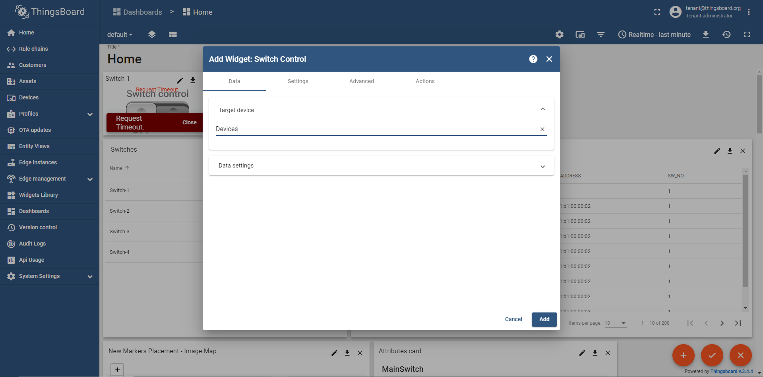

**7**

**6**

In Advance give a Json format to send the data.

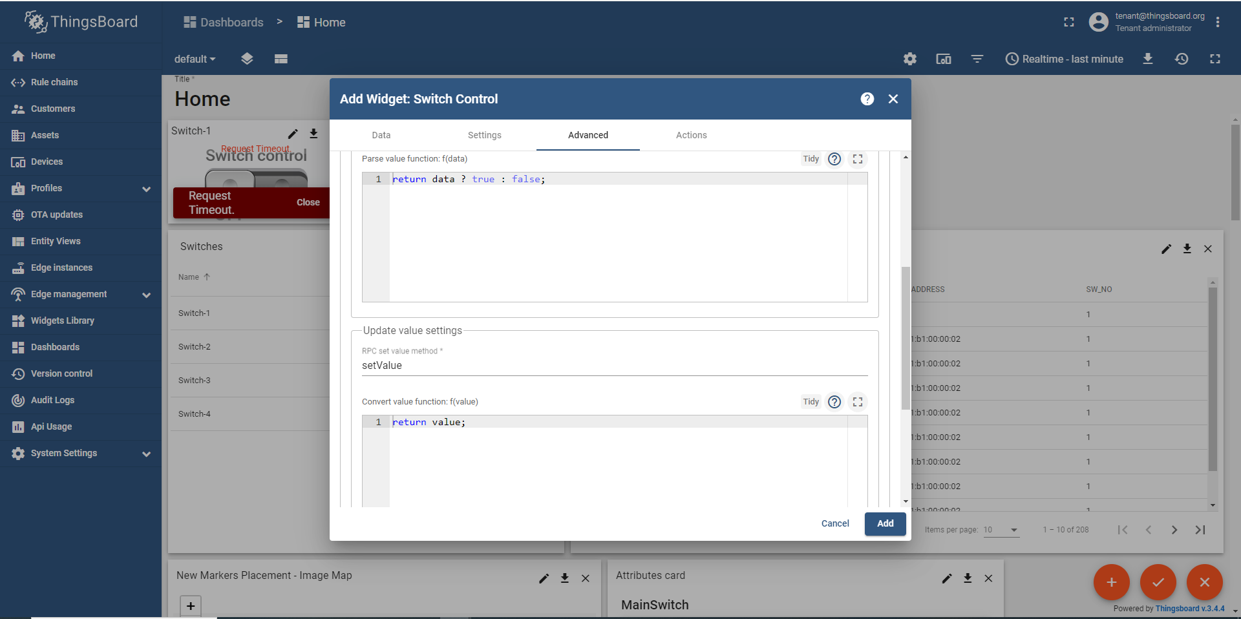

**9**

**8**

As you can see how I given here and save it-

